Exercise: Basic Charts

This Excel file contains fictitious pharmaceutical sales information. Create a Tableau worksheet to answer each of the following questions:

**FILE to use:** [Pharmaceutical data exercise.twbx](https://twu.instructure.com/courses/2919904/files/170154673/download?wrap=1)

1. Recreate the following visualization of the average prescription price over time:

The x and y axis do not have to match exactly. I will be checking for if the bars match and if you have the filter in place.

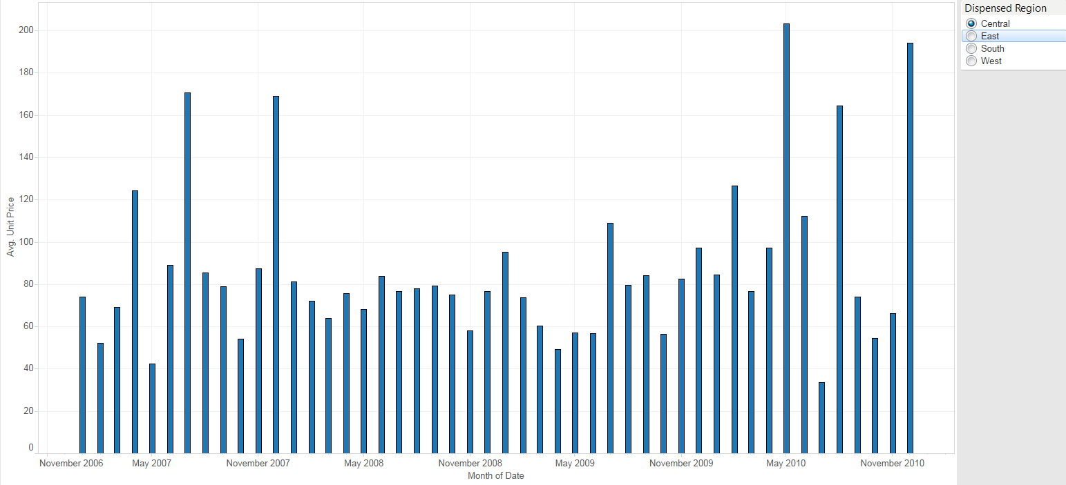

*Down below is my graph exactly how you wanted it.*

1. What is the average unit price in November 2008 in the South region? **87.3**

